==================================

DATABASE SCHEMA FOR WALLET SYSTEM

==================================

Note: The SQL script present in the resources folder in the application is responsible for creation of the below tables in the database. It also contains statements to add sample entries to be added in database.

Spring boot’s embedded H2-Database is used for testing.

=====================================================================================

TABLE WALLET_USER -> To store all the users registered on wallet system. This table has one to many mapping with the USER_TRANSACTION table.

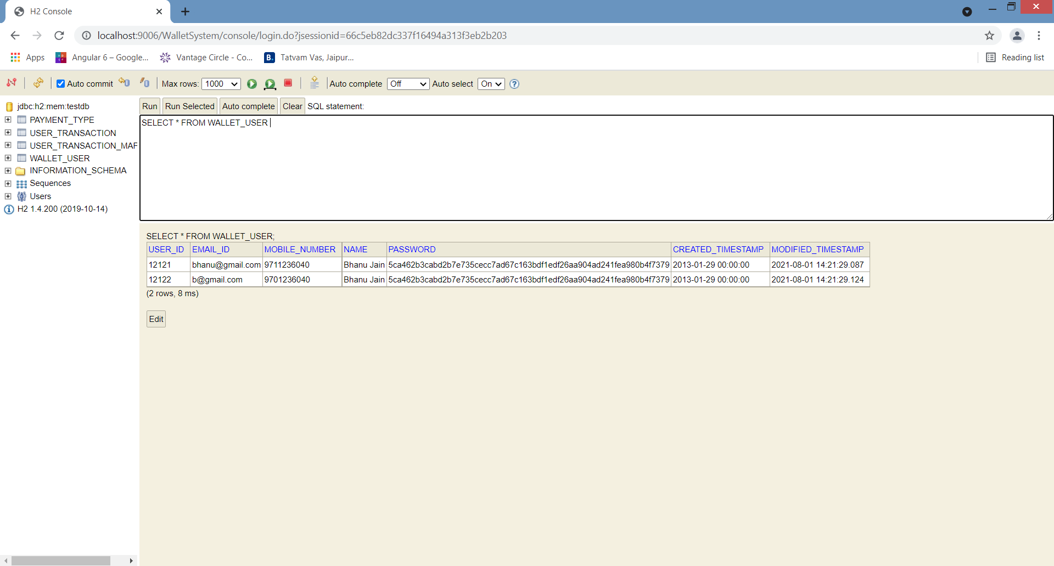

=====================================================================================

TABLE PAYMENT_TYPE -> To hold all the possible payment types possible on current wallet System. This table has a one to one mapping with the USER_TRANSACTION table.

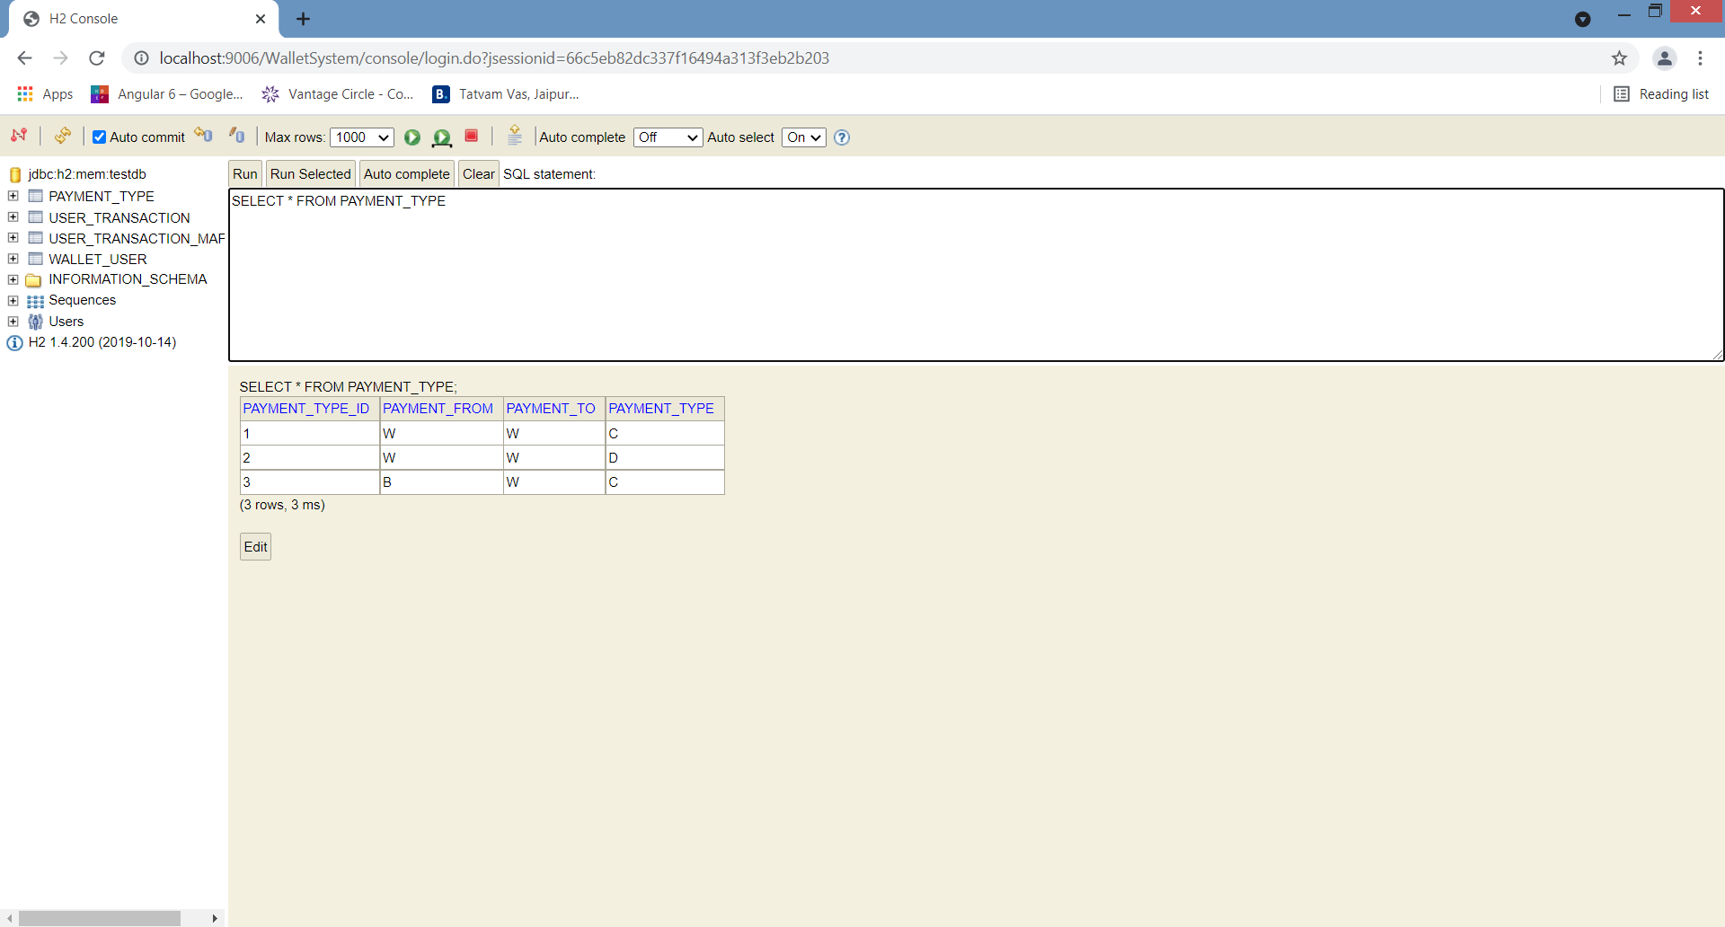

1. C denotes CREDIT, D denoted DEBIT
2. W denoted WALLET, B denoted BANK

=====================================================================================

TABLE USER_TRANSACTION -> To hold all the user transactions made by different users in wallet system.

This table has many to one mapping with the WALLET_USER table and one to one mapping with the PAYMENT_TYPE table.

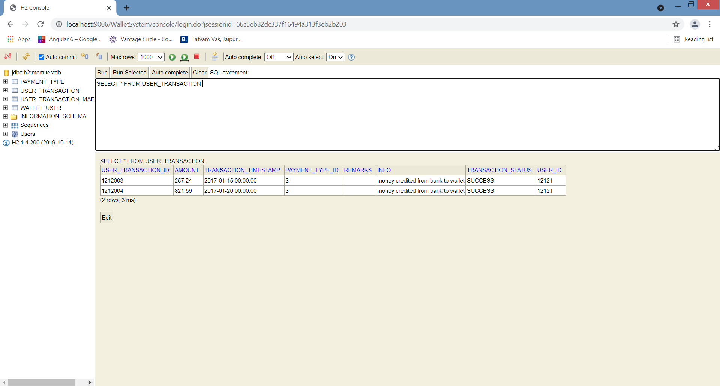

TABLE USER_TRANSACTION_MAPPING -> To map the users and their transactions together. This tabl;e has a composite primary key combined from USER_ID(primary key of WALLET_USER table) and USER_TRANSACTION_ID(primary key of USER_TRANSACTION table).

